PRC Risk Management

Revision History
Version | Date | Author | Reviewer | Approver | Change Summary

Table of Contents

1 Purpose 4
2 Scope 4
3 Acronyms & Abbreviations 4
4 Risk Management Procedure 5
4.1 Risk Management Process Steps 5
5 Generic Techniques / Methods for Ensuring the Effectiveness of the Risks Management 8
5.1 Risk audits – Conducted periodically by the concerned RO himself or by the BU Head or the CRO designate examining and documenting the effectiveness of risk responses in dealing with identified risks and their root causes, as well as the effectiveness of the risk management process. The BU Head’s responsibility is to ensure the risk audits are performed at an appropriate frequency, as defined earlier in the risk management plan. The format for the audit and its objectives should be clearly defined before the audit is conducted. 8
5.2 Variance and trend analysis – Using performance information for comparing planned results to the actual results, in order to control and monitor risk events and to identify trends in the Unit’s operations / execution. Outcomes from this analysis may forecast potential deviation (at completion) from cost and schedule targets. 8
5.3 Technical performance measurement – Comparing technical accomplishments during project execution to the project management plan’s schedule. It is required that objectives will be defined through quantifiable measures of technical performance, in order to compare actual results against targets. 8
5.4 Status meetings – Unit risk management should be an agenda item at periodic status meetings, as frequent discussion about risk makes it more likely that people will identify risks and opportunities or advice regarding responses 8
6 Reference 9

Purpose
Information Technologies (IT) are vital to <Org Name> operations. They are tools that improve the quality and efficiency of our daily routine work. IT is the repositories of critical and sometimes highly proprietary corporate information. The improper access to or the destruction of these resources will have serious consequences for the <Org Name>. The purpose of this procedure is to ensure that the IT resources are appropriately protected from destruction, alteration or unauthorized access and provide the step by step process to ensure all the critical processes are followed.

Scope
Applicable to all employee, customer, vendor, contractor, consultant, trainee, faculty, or any other individual who have access to any of the Information or Information Processing Facilities like Servers, Networks, Applications, Databases, Desktops, Laptops and any printed or hardcopy of information.

Acronyms & Abbreviations
Abbreviation | Description
CRO | Chief Risk Officer
RO | Risk Officer
BU | Business Head
ISG | Information Security Group

Risk Management Procedure
Entry Criteria
- This is an ongoing process at <Org Name>
INPUTS
- Business Requirements
- ISMS Policies
Tasks
# | Task | Responsibility

Risk Management Process Steps
1. | - Communicate and consult.  - Establish the context.  - Identify the risks.  - Analyze the risks.  - Evaluate the risks.  - Treat the risks.  - Monitor and review. | CISO/ISG/IT
1.1. | - Communicate and consult  - Communication and consultation aim to identify who should be involved in assessment of risk (including identification, analysis and evaluation) and it should engage those who will be involved in the treatment, monitoring and review of risk.  - Determine at the outset whether a communication strategy and/or plan is required  - Determine the best method or media for communication and consultation  - The significance or complexity of the issue or activity in question can be used as a guide as to how much communication and consultation is required: the more complex and significant to the organization, the more detailed and comprehensive the requirement. | CISO/ISG/IT
1.2 | - Establish the Context  1-Establish the internal context- The objectives and goals of a business, project or activity must first be identified to confirm that all significant risks are understood so as to ensures that risk decisions always support the broader goals and objectives of the business  2-Establish the external context- To understand the overall environment in which a business operates and includes an understanding of the clients’ or customers’ perceptions of the business. An analysis of these factors will identify the strengths, weaknesses, opportunities and threats to the business in the external environment  3-Establish the risk management context- Before beginning a risk identification exercise, it is important to define the limits, objectives and scope of the activity or issue under examination.  Define the objectives of the activity, task or function and simultaneously identify any legislation, regulations, policies, standards and operating procedures that need to be complied with  Decide on the depth of analysis required and allocate resources accordingly.  4- Develop risk criteria- Establish the organizational risk criteria  To allow the business to clearly define unacceptable levels of risk.  Decide or define the acceptable level of risk for each activity  Determine what is unacceptable  Identify who is responsible for accepting risk and at what level  5- Define the structure for risk analysis- Isolate the categories of  risk that is required to be managed so as to get a greater depth and  accuracy in identifying significant risks.  The chosen structure for risk analysis will depend upon the type of  activity or issue, its complexity and the context of the risks. | CISO/ISG/IT
1.3 | - Identify the Risk  The aim of risk identification is to identify possible risks that may affect, either negatively or positively, the objectives of the business and the activity under analysis.  Answers to questions like what, how and why can identify the risk as it happens.  Methods applied by the organization to identify risks within the business are:  - Brainstorming with staff or external stakeholders  - Researching the economic, political, legislative and operating environment  - Conducting interviews with relevant people and/or organizations  - Undertaking surveys of staff or clients to identify anticipated issues or problems  - Flow charting a process  - Reviewing system design or preparing system analysis techniques | CISO/ISG/IT
1.4 | - Analyze the Risk  The risk analysis step assists in determining which risks have a greater consequence or impact than others.  Risk analysis involves combining the possible consequences, or impact, of an event, with the likelihood of that event occurring. The result is a ‘level of risk’. That is: Risk = consequence x likelihood  The elements considered for risk analysis are as follows:  1. Identify existing strategies and controls that act to minimize negative risk and enhance opportunities.  2. Determine the consequences of a negative impact or an opportunity (these may be positive or negative).  3. Determine the likelihood of a negative consequence or an opportunity.  4. Estimate the level of risk by combining consequence and likelihood.  5. Consider and identify any uncertainties in the estimates. | CISO/ISG/IT
1.5 | - Evaluate the Risk  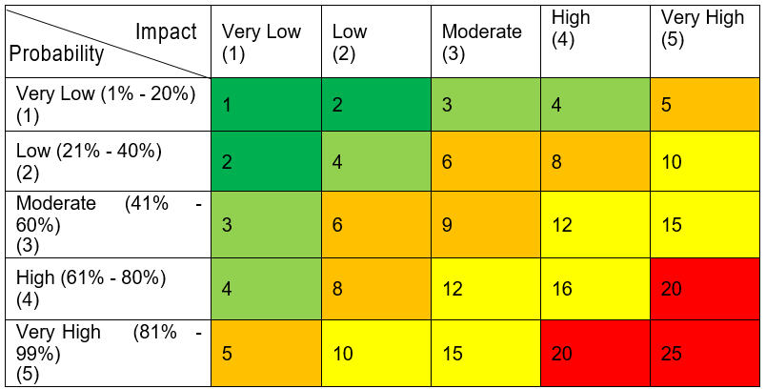  Risk evaluation involves comparing the level of risk found during the analysis process with previously established risk criteria, and deciding whether these risks require treatment.  The result of a risk evaluation is a prioritized list of risks that require further action  This step is about deciding whether risks are acceptable or need treatment. The organization decides on the risk acceptance criteria based on the below evaluation:  A risk may be accepted for the following reasons:  • The cost of treatment far exceeds the benefit, so that acceptance is the only option (applies particularly to lower ranked risks)  • The level of the risk is so low that specific treatment is not appropriate with available resources  • The opportunities presented outweigh the threats to such a degree that the risks justified  • The risk is such that there is no treatment available, for example the risk that the business may suffer storm damage. | CISO/ISG/IT
1.6 | - Treat the Risk  Risk treatment involves, the organization, identifying options for treating or controlling risk, in order to either reduce or eliminate negative consequences, or to reduce the likelihood of an adverse occurrence. Risk treatment should also aim to enhance positive outcomes. The organization through its risk treatment process arrives at conclusive decisions as to which treatment plan to select and pursue from the below options:  1- Avoid the risk  2- Change the likelihood of the occurrence  3- Change the consequences  4- Share the risk  5- Retain the risk | CISO/ISG/IT
1.7 | - Monitor and Review  Risks are monitored by the organization periodically to ensure changing circumstances do not alter the risk priorities. Very few risks will remain static, therefore the risk management process needs to be regularly repeated, so that new risks are captured in the process and effectively managed.  The organizational risk management plan at a business level is reviewed at least on an annual basis. The organization ensures that it is executed in an effective way by combining risk planning or risk review with annual business planning. | CISO/ISG/IT

Generic Techniques / Methods for Ensuring the Effectiveness of the Risks Management

Risk audits – Conducted periodically by the concerned RO himself or by the BU Head or the CRO designate examining and documenting the effectiveness of risk responses in dealing with identified risks and their root causes, as well as the effectiveness of the risk management process. The BU Head’s responsibility is to ensure the risk audits are performed at an appropriate frequency, as defined earlier in the risk management plan. The format for the audit and its objectives should be clearly defined before the audit is conducted.

Variance and trend analysis – Using performance information for comparing planned results to the actual results, in order to control and monitor risk events and to identify trends in the Unit’s operations / execution. Outcomes from this analysis may forecast potential deviation (at completion) from cost and schedule targets.

Technical performance measurement – Comparing technical accomplishments during project execution to the project management plan’s schedule. It is required that objectives will be defined through quantifiable measures of technical performance, in order to compare actual results against targets.

Status meetings – Unit risk management should be an agenda item at periodic status meetings, as frequent discussion about risk makes it more likely that people will identify risks and opportunities or advice regarding responses
Verification
- Process Excellence team shall verify the implementation of activities during the periodic audits. Senior Management shall verify the implementation during the status reviews.
OUTPUTS
- Risk Management Plan
- Enterprise Risk Classification
- Risk Treatment plan
- Risk and Opportunity Register
Exit Criteria
- This is an ongoing process.
- With respect to projects, in case of project statutory, regulatory or contractual requirements, this process will end during closure of that specific.
Measurement
Appropriate measurements shall be collected and analyzed as per the Measurements and Improvement procedure.

Reference
- Risk Management Process.
- Risk management Guideline
- Enterprise Risk Register

